NBCUniversal Forms In-Game Ad Partnership
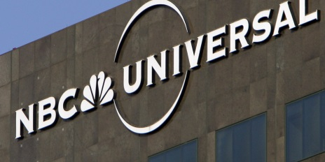
NBCUniversal is making its foray into in-game ads through a partnership with Tel Aviv-based Anzu that gives clients in the US and UK exclusive access to inventory on Microsoft Xbox, Ubisoft and other mobile, PC and console gaming partners. Advertisers can access contextual and programmatic ads, along with viewability insights, audience verification and fraud detection through NBCU's One Platform.
The Drum (free registration) 2.28.22
https://www.thedrum.com/news/2022/02/28/nbcuniversal-pivots-game-advertising-with-anzu-tie-up

