NBCUniversal Hit With $2.8B Lawsuit Over Critical News Report
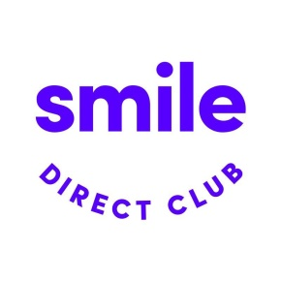
“SmileDirectClub gave NBC every opportunity to retract this defamatory report and correct the record voluntarily,” said the action against NBCUniversal Media LLC and reporter Vicky Nguyen that hit the docket in the Tennessee courts on Monday from the teledentistry organization over a critical February report from NBC News. “NBC chose not to so,” says the $2.85 billion-seeking suit.
Deadline 5.18.20
https://deadline.com/2020/05/nbc-lawsuit-news-smiledirectclub-nightly-news-report-nbcuniveral-vicky-nguyen-1202937773/
Image credit:
https://hp-h.assetsadobe.com/is/image/content/dam/hpi/press/press-releases/2019/hp-and-smile-direct-club-collaborate/imgo.jpg?$large$

