NBCUniversal Steers ShoppableTV Toward Cable
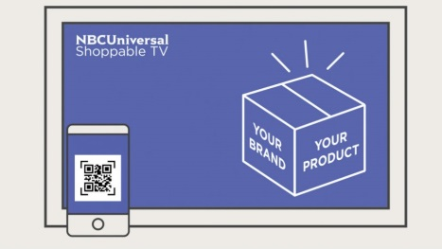
Comcast's NBCUniversal is combining smartphones with home shopping to produce ShoppableTV, which will run across many of the company's assets, including Bravo, E!, CNBC Prime and the USA Network. Viewers can buy products they see on the programming by scanning on-screen QR codes which will link them to websites where they can make purchases.
TechCrunch 5/6/19
https://techcrunch.com/2019/05/06/nbcuniversals-scannable-shoppabletv-takes-viewers-directly-to-e-commerce-sites/

