NCTA Praises $5B Broadband Bill For Unserved Areas
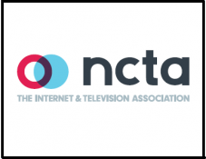
A pair of US senators introduced legislation that calls for the government to pump $5 billion into a fund-matching program to bring broadband service to unserved areas over six years. NCTA--The Internet and Television Association issued a statement welcoming the proposal, saying that it particularly approved of "the legislation's emphasis on directing funds to areas that need them the most...”
Multichannel News 6/28/19
https://www.multichannel.com/news/senators-collins-jones-propose-5-billion-plan-for-rural-broadband-buildout

