Nebraska Broadcasters Unite To Help Flood Victims
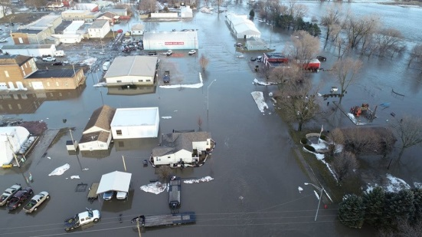
Nebraska Broadcasters Association member radio and TV stations came together last Friday to hold flood relief drives that yielded $441,919 in donations to the American Red Cross. “This couldn’t have happened without the voluntary efforts of countless people from amongst our station membership,” said Jim Timm, NBA’s president.
TVNewsCheck 3.26.19
https://marketshare.tvnewscheck.com/2019/03/26/nebraska-broadcasters-unite-to-help-flood-victims/?utm_source=Listrak&utm_medium=Email&utm_term=Nebraska+Stations+Unite+To+Help+Flood+Victims&utm_campaign=5+Days+Of+March+Madness%3a+Ratings+Up%2c+Spend+Down
Image credit:
https://s3-ca-central-1.amazonaws.com/quincy-network/wp-content/uploads/sites/4/2019/03/Ponca-Flooding4.jpg

