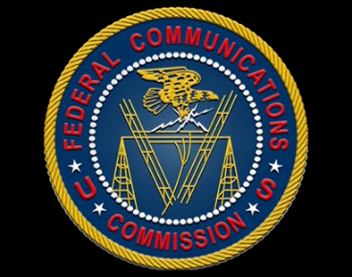
FCC Plans April 25 Vote On Net Neutrality
An April 25 vote is likely to reinstate net neutrality rules, said Jessica Rosenworcel, chair of the FCC. The plan would apply common carrier rules to internet service providers.
Deadline Hollywood 4/3/24
https://deadline.com/2024/04/net-neutrality-fcc-1235874717/

