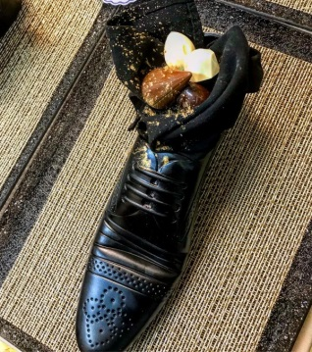
Netanyahu Puts Wrong Foot Forward
There aren’t that many cultures where putting a shoe on the dining room table is acceptable behavior, but for the Japanese there is clear etiquette against allowing outdoor shoes inside.
The Washington Post 5.7.18
https://www.washingtonpost.com/news/worldviews/wp/2018/05/07/netanyahu-puts-wrong-foot-forward-by-serving-japans-abe-dessert-in-a-shoe/?utm_term=.482e6ad4f780&wpisrc=nl_most&wpmm=1
Image credit:
https://cdn.jerusalemonline.com/images/AAABecca/choshoesegevmoshe0705.jpg

