Netflix Announces Extra Content Feature for Dual-Screen Viewing
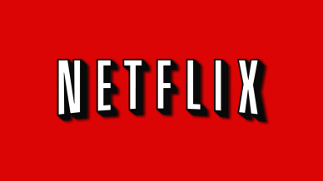
Netflix is set to debut a new feature this year that allows people to browse supplemental content online while also using the streaming service. A Nielsen study shows that 62% of people in North America and 58% worldwide browse the Web while also watching video content. The initial offering uses cataloged content from Netflix, but it may become available to third-party providers.
Business Insider 2/25/16
http://www.businessinsider.com/netflix-second-screen-feature-for-movies-tv-shows-2016-2

