Netflix Orders Batch of Japanese Animation
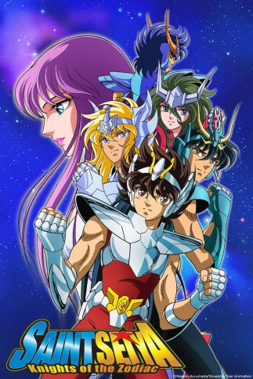
Netflix has ordered more than 20 new animation titles in Japan, including a reboot of the classic anime and manga “Saint Seiya.” Greg Peters, Netflix’s chief product officer, said Netflix was focused on working with Japanese studios and production companies to meet the high demand for animated shows.
Variety 8.18.17
http://variety.com/2017/tv/news/netflix-orders-japanese-animation-saint-seiya-reboot-1202527941/
Image source:
http://img1.ak.crunchyroll.com/i/spire4/7b09fbb42da3d9fa613ec1d025cf41df1411687266_full.jpg

