Netflix to Add 600 Hours of Original Programming, Focus on Families
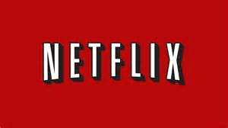
Netflix is "doubling down on kids and families" this year as it adds 600 hours of original programming to its platform, Chief Content Officer Ted Sarandos said. The company is on track to add 20 original children's programs in 2016 and is sticking to its policy of keeping ratings under wraps, Sarandos added.
Broadcasting & Cable 1/17/16
http://www.broadcastingcable.com/news/programming/tca-sarandos-netflix-staying-out-ratings-arms-race/147053

