Netflix Will Stop Working on Older Samsung Smart TVs Next Month
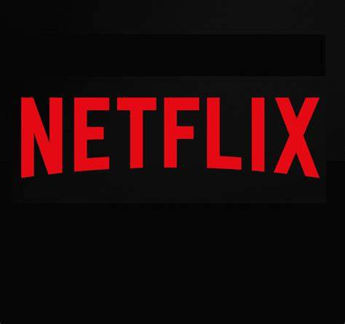
"On December 2nd, Netflix will no longer be supported on a small number of older devices due to technical limitations," a Netflix representative said in an email. "We've notified all impacted members with more information about alternative devices we support so they can keep enjoying Netflix uninterrupted."
CNET 11.5.19
https://www.cnet.com/news/best-holiday-gifts-under-100-2019/?utm_source=Listrak&utm_medium=Email&utm_term=Netflix+Will+Stop+Working+On+Older+Samsung+Smart+TVs+Next+Month&utm_campaign=More+Earnings+From+Tegna,+Gray,+Fox,+Dish

