New FCC Tool Lets Public Weigh In On Broadband Maps
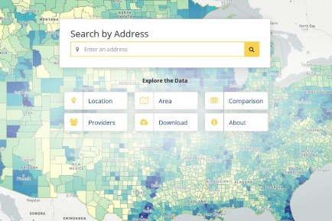
The Federal Communications Commission will soon let consumers provide information about broadband access, acting Chair Jessica Rosenworcel announced. A recently-formed task force will use the information to create more accurate coverage maps.
Next TV 3.16.21
https://www.nexttv.com/news/fcc-launching-public-input-mapping-tool
Image credit:
https://icdn6.digitaltrends.com/image/fcc-internet-map-via-mapbox-us-900x600.jpg

