New Jersey Media Group to Convert to Non-Profit Status
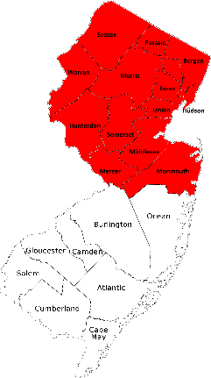
The New Jersey Hills Media Group has said that it intends to transfer ownership of its 14 weekly newspapers to a new nonprofit, the Corporation for New Jersey Local Media. The Corporation says that it is the “first conversion of an established weekly newspaper group to non-profit ownership in the nation.” The group is hoping to raise $500,000 in a community fundraising drive to cover the conversion.
Corporation for New Jersey Local Media 1.29.21
https://newsweneed.org/
Image credit:
https://securityshredding.net/wp-content/uploads/2014/01/nj-counties-4.png

