New Jersey Passes Law Protecting Student Press Freedom
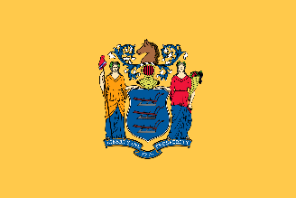
The legislation, which was first introduced in New Jersey in 2015, prohibits the censorship of student journalists except in narrow circumstances. It will also protect student media advisers from retaliation when they refuse to illegally censor their students.
Student Press Law Center 6.24.21
https://splc.org/2021/06/new-jersey-passes-law-protecting-student-press-freedom/?utm_source=Student+Press+Law+Center+newsletter&utm_campaign=eec2294355-EMAIL_CAMPAIGN_4_26_2018_COPY_01&utm_medium=email&utm_term=0_8fab1c40ea-eec2294355-138474105
Image credit:
http://www.barber-schools.org/wp-content/uploads/2013/02/state-flag-new-jersey.png

