New Life for a Cult Comedy Favorite
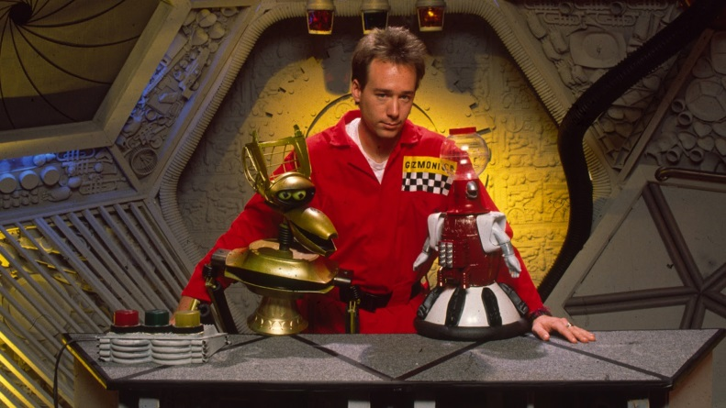
A Kickstarter project to bring back cult favorite Mystery Science Theater 3000 is more than a quarter of the way to its goal. "The raised funds will go toward the production of the new episodes, backer rewards and cost associated with running the campaign," said Shout! Factory founders Richard Foos, Bob Emmer and Garson Foos.
Adweek 11.1.15
http://www.adweek.com/news/television/kickstarter-campaign-aims-bring-back-mystery-science-theater-3000-168059

