Nexstar Adds Quartet of W.Va. TV Outlets
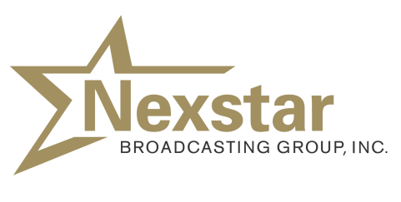
Nexstar Broadcasting is spending $130 million to acquire three CBS affiliates and an NBC affiliate from West Virginia Media Holdings. Nexstar -- following the closing of this and other pending deals -- will own, operate, program or handle sales and operations for 115 TV outlets in 62 markets in 25 states.
TVNewsCheck 11/17/15
http://www.tvnewscheck.com/article/90089/nexstar-buys-4-wva-tvs-for-130m

