Nexstar to Acquire Media General; Meredith Walks Away
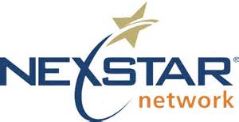
Nexstar is moving forward with its $4.6 billion deal to purchase Media General, following Meredith Corp.'s decision to walk away from its merger plan with Media General. Meredith will receive a $60 million breakup fee and have the right to acquire some of Media General's TV and digital assets. Nexstar Media Group, as the combined companies will be known, will consist of 171 full-power TV outlets in 100 markets, reaching 39% of US homes.
Broadcasting & Cable 1/27/17
http://www.broadcastingcable.com/news/currency/nexstar-agrees-buy-media-general-46b/147293

