NFL, Amazon in $50M 1-Year Streaming Deal
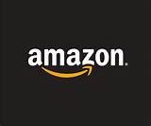
Amazon has bought the rights to the league’s streaming package, and will offer the games for free to its Amazon Prime subscribers around the world. Amazon is paying around $50 million for the 10 games it will show next fall. That’s a big increase from the $10 million Twitter paid for last year’s games.
Recode 4.4.17
https://www.recode.net/2017/4/4/15183786/twitter-lost-nfl-football-streaming-video-tv-deal-amazon

