NFL Launches Snapchat Discover Channel
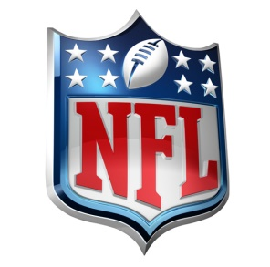
The National Football League has teamed with Snapchat to become the first-ever sports league to launch its own Discover channel. The partnership will include Live Stories for all games, including the Super Bowl, and all teams will have customized geofilters close to their stadiums and other key locations.
Mashable 8/2/16
http://mashable.com/2016/08/02/snapchat-nfl-discover-deal/#jC4MMqUnuPqu

