NFL Opening Week Has Highest Viewership Since 2017
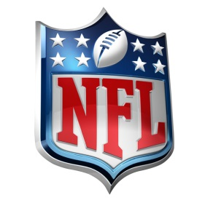
An average of 17.4 million people watched NFL games across a combination of digital media and television during the season's opening week -- the highest average since 2017. The match between the Dallas Cowboys and the Tampa Bay Buccaneers on Sept. 9 had an average viewership of 26.4 million.
ESPN 9/14/21
https://www.espn.com/nfl/story/_/id/32211359/nfl-opening-week-ratings-average-174-million-7-20

