Nielsen: Nov. Universe Estimates are Accurate
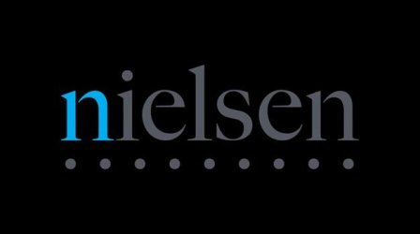
Nielsen has confirmed that the declines in its November 2016 Cable Network Coverage Area Universe Estimates are accurate. "The month-over-month decline in coverage that most cable networks saw was driven primarily by an overall decline of approximately half a percentage point (0.55) in the Cable Plus universe," Nielsen said.
RBR.com 11/4/16
http://rbr.com/nov-ue-ok-omg/

