Nielsen Expands Ratings to Align with Current Trends
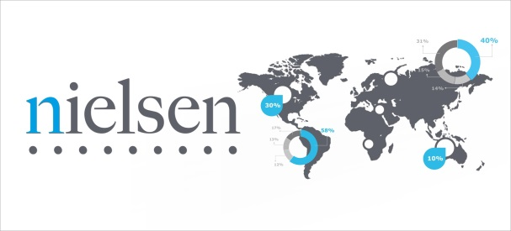
Nielsen has expanded its ratings measurement to encompass out-of-home and delayed viewing, the absences of which have contributed to recent declines in ratings. The data show that when the seven-day window was extended to 35 days, some shows saw double-digit increases.
Deadline.com 4/18/17
http://deadline.com/2017/04/nielsen-significant-tv-viewing-lifts-new-measures-1202071472/

