Nielsen Ratings to Include Facebook and Twitter TV Chatter
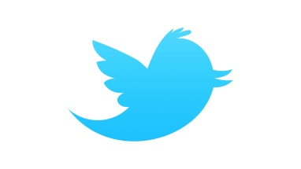
Nielsen has announced it will use the social chatter about television shows from Facebook and Twitter in its measurement system. “Social Content Ratings" is a move to counteract criticism that the company wasn't capturing digital viewing figures.
The New York Times 1/20/16
http://www.nytimes.com/2016/01/20/business/media/nielsen-to-use-facebook-and-twitter-in-new-ratings-system.html?WT.mc_id=SmartBriefs-Newsletter&WT.mc_ev=click&_r=0

