Nielsen Says Enhanced CBET Tests Look Good
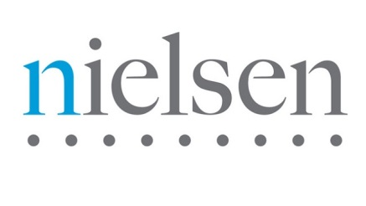
Some 4,000 out of 11,000 stations have installed Nielsen's enhanced Critical Band Encoding Technology PPM encoding technology. Baltimore leads the pack with 65% of clients converted. Testing continues in this area of the legacy versus enhanced CBET on client stations. Experts at the Nielsen client conference, Thursday, show meters were detecting 100% of the watermark codes for most music formats with legacy CBET, and still are with enhanced CBET.
Radio Ink 12.3.15
http://www.radioink.com/Article.asp?id=2992535&spid=24698

