Night Media Launches $20 Million Venture Fund Backed By Top YouTubers
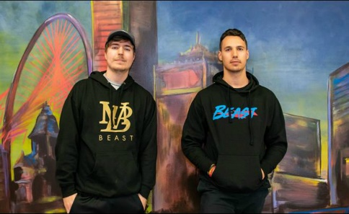
The fund will “lean into early-stage investments in gaming, consumer, and the creator economy,” Night Media says. Night Media founder and CEO Reed Duchscher told TechCrunch the fund is writing initial checks of up to $300,000 for consumer-facing startups, and is especially interested in companies focused on gaming and digital content creators.
Tubefilter 3.19.21
https://www.tubefilter.com/2021/03/19/night-media-20-million-venture-fund-mrbeast/?utm_source=Tubefilter+Newsletters&utm_campaign=7fb012957f-Tubefilter+Daily+Recap+-+2016-09-15_COPY_01&utm_medium=email&utm_term=0_09c509c94c-7fb012957f-414175190&mc_cid=7fb012957f&mc_eid=a906555dbd
Image credit:
https://www.tubefilter.com/wp-content/uploads/2019/01/mrbeast-night-media-representation.jpg

