Nissan Integrates Influencers in a Winning Strategy
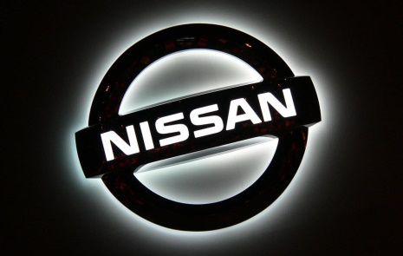
Nissan benefits from integrating influencers throughout its marketing strategy rather than using them for single campaigns, Nicolas Chabot and Gemma Dodd from Traackr explain. A video spot created by influencer UNILAD, showcasing the car's dog-friendly customizations, generated more than 63 million views.
Econsultancy 10/5/17
https://econsultancy.com/blog/69475-how-nissan-works-with-influencers-at-each-stage-of-its-marketing-funnel

