Federal Court Shutters, Fines Pirate Site Nitro TV
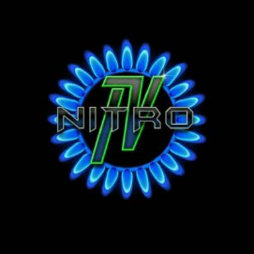
Nitro TV must pay $51 million in fines under a federal court order that also shuts down the website for violating copyright infringement laws. The company's resellers offered pirated content at $20 per month.
Next TV 12.2.22
https://www.nexttv.com/news/us-court-says-stream-stealer-nitrotv-must-pay-dollar51-million?utm_term=A25693A1-51B6-4112-BDE4-56BD420E983F&utm_campaign=3E572E13-3FBC-11D5-AD13-000244141872&utm_medium=email&utm_content=B3C34B04-FC00-44B5-AAB4-291ECDFC3C75&utm_source=SmartBrief

