‘The Wire’ Creator Says He’ll Pull Upcoming HBO Series From Texas Over Abortion Law
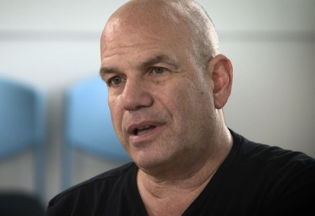
“As an employer, this is beyond politics,” Simon wrote. “I’m turning in scripts next month on an HBO non-fiction miniseries based on events in Texas, but I can’t and won’t ask female cast/crew to forgo civil liberties to film there. What else looks like Dallas/Ft. Worth?”
Hollywood Reporter 9.21.21
https://www.hollywoodreporter.com/tv/tv-news/texas-abortion-law-david-simon-hbo-1235018353/
Image credit:
https://www.washingtonpost.com/resizer/9zhB5uheW2BXeZ-dCW-6RFVr-JY=/1484x0/arc-anglerfish-washpost-prod-washpost.s3.amazonaws.com/public/MJAYTIGJ2U5FXPBNEIV2CJPFWY.jpg

