In A First, Norway Bids Farewell to FM Radio
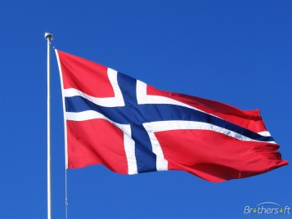
It’s digital that’s killing FM radio, at least in Norway, which this year will become the first country to phase out this form of broadcasting entirely. The government found that FM radio costs were eight times higher than digital and that more channels would be made available to residents with the move to DAB.
MediaLife 9.9.17
http://www.medialifemagazine.com/first-norway-bids-farewell-fm-radio/

