Now Easier for a Foreign Investor to Own a Part of, or All of, a US Broadcast Station
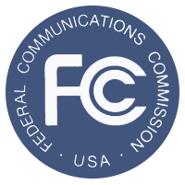
Further, the FCC decision allows for an entity with a foreign-ownership interest, once approved by the FCC, will be able to apply that approval to the subsequent acquisition of any other television or radio stations. Until 2013, the FCC banned any foreign investment in US broadcast stations that were greater than 25%.
RadioInk 9.29.16
http://radioink.com/2016/09/29/fccs-foreign-ownership-ruling-means/?utm_source=ActiveCampaign&utm_medium=email&utm_content=What+The+FCC+s+New+Ownership+Rules+Mean+To+You&utm_campaign=FRIDAY+-+9+30+-+WHAT+THE+FCC+S+OWNERSHIP+RULING+MEANS+TO+YOU

