NPR Journalist, Translator Killed In Afghanistan
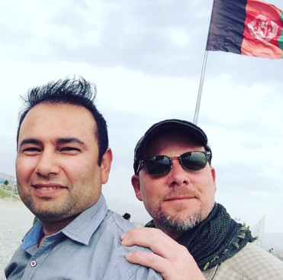
David Gilkey, a veteran news photographer and video editor for National Public Radio, and an Afghan translator, Zabihullah Tamanna, were killed while on assignment in southern Afghanistan on Sunday, the network says. Gilkey and Tamanna were traveling with an Afghan army unit near Marjah in Helmand province when the convoy came under fire and their vehicle was struck.
The Associated Press 6.6.16
http://www.tvnewscheck.com/article/95274/npr-journalist-translator-killed-in-afghanistan?utm_source=Listrak&utm_medium=Email&utm_term=NPR+Journalist%2c+Translator+Killed+In+Afghanistan&utm_campaign=Buyers+List+Fall%e2%80%99s+Least+Promising+New+Shows

