NPR Launches Podcast Bundles To Support Local Radio
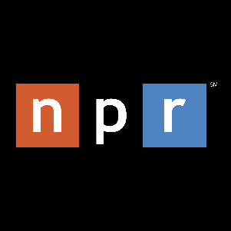
Public radio audiences in 34 US markets will gain an all-you-can-listen NPR+ option when they pledge $8 per month (or $96 annually) to their local public radio station. Radio stations promote NPR podcasts but have not benefitted from them financially, and less than 1% of NPR digital listeners contribute to radio stations, says NPR exec Joel Sucherman.
Inside Radio (free content) 11.4.22
https://www.insideradio.com/free/npr-tapping-its-podcast-subscriptions-to-funnel-donor-dollars-to-local-stations/article_caf83862-5c10-11ed-a57b-9fe63c4fff10.html

