Number of People Using Mobile-Only Internet Soars
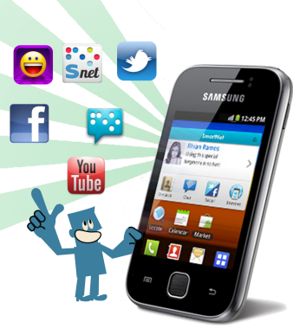
A new forecast from eMarketer projects mobile-only users will hit 40.7 million this year. That’s up 27 percent from 2015, when there were only 32.1 million of them. By 2021, there will be 52.3 million mobile-only users, representing nearly a fifth of all U.S. internet users.
MediaLife 2.21.17
http://www.medialifemagazine.com/number-people-using-mobile-internet-soars/
Image source:
http://technogiants.net/wp-content/uploads/2013/11/Mobile-Internet.png

