N.Y. Examines Whether Premium Internet Tiers Deliver on Speed Promises
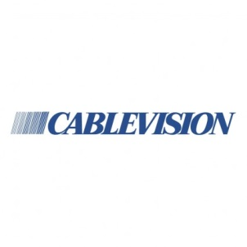
The New York State Attorney General's Office is investigating whether premium Internet tiers from Cablevision, Verizon and Time Warner Cable are producing Internet speeds as fast as their advertisements promise. There exists the "possibility that interconnection arrangements may in some instances render irrelevant any benefit," said Tim Wu, the new senior enforcement counsel in the attorney general's office.
Advertising Age 10/26/15
http://adage.com/article/media/broadband-providers-face-york-scrutiny-speed-claims/301066/

