Obama Launches Broadband-Access Program for Low-Income Residents
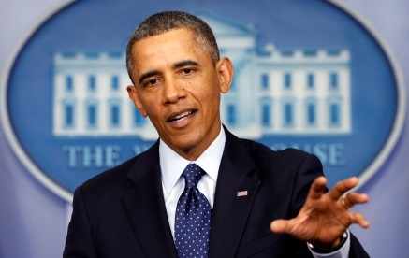
President Barack Obama on Wednesday announced a pilot program called ConnectHome, which is designed to give public housing residents access to free or low-cost broadband. The effort is meant to help families -- especially those with children -- who have computers but cannot afford broadband service. Cox Communications is among eight Internet service providers participating in the program.
TechCrunch 7/15/15
http://techcrunch.com/2015/07/15/internet-for-everyone/

