Ogilvy, Chemours Urge Girls to Pursue Science
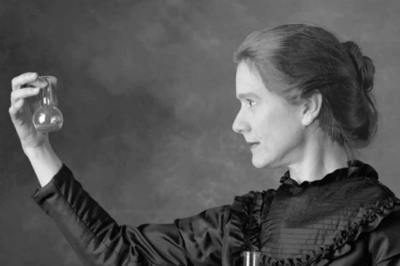
Ogilvy New York has created three YouTube spots for chemical brand Chemours that relay the stories of three women responsible for scientific breakthroughs. One spot highlights Marie Curie, with an actor imagining her voice as she describes the societal barriers she overcame to become the first individual to win two Nobel Prizes.
Adweek 10/23/17
http://www.adweek.com/agencies/this-historical-psa-powerfully-encourages-girls-to-defy-stereotypes-and-pursue-the-sciences/
Image credit:
http://wac.450f.edgecastcdn.net/80450F/laramielive.com/files/2013/03/MarieCurie.jpg

