Olivia de Havilland, Now 102, Will Take 'Feud' to Supreme Court
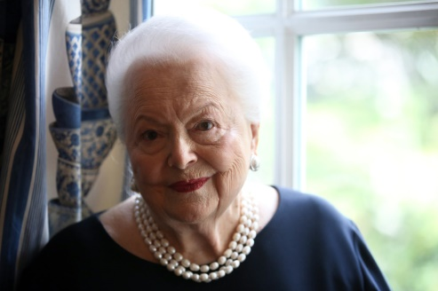
She's eyeing First Amendment standards after being dismayed by Ryan Murphy's FX series, Feud: Bette and Joan, which she contends falsely portrayed her in a role played by Catherine Zeta-Jones as a vulgar hypocrite and gossip. De Havilland sued in June 2017 with claims of infringement of common law right of publicity, false light and unjust enrichment.
The Hollywood Reporter 8.23.18
https://www.hollywoodreporter.com/thr-esq/actress-olivia-de-havilland-now-102-will-take-feud-supreme-court-1137142?utm_source=Listrak&utm_medium=Email&utm_term=Olivia+de+Havilland+Taking+%26%23039%3bFeud%26%23039%3b+To+Supreme+Court&utm_campaign=Senate+Moves+To+Require+Drug+Prices+In+Ads
Image credit:
https://media.npr.org/assets/img/2016/07/01/ap_16170581114937_custom-b7183a510c16410fbea6865dbbfc9f822ea0b41d-s1200-c85.jpg

