One Very Sweet Spectrum Auction: $86 Billion
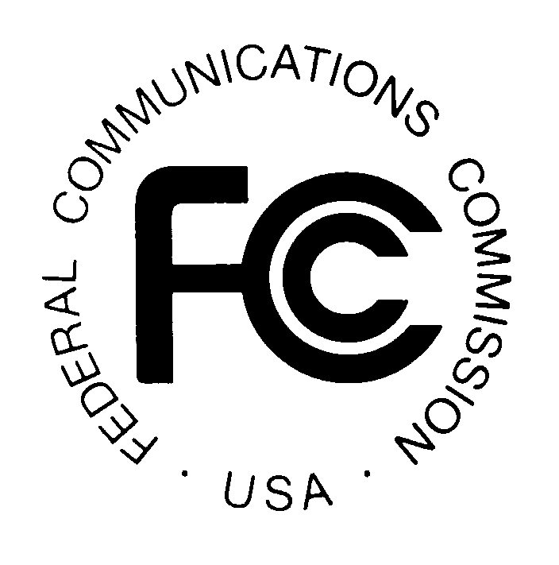
Wells Fargo Securities, BTIG and others had estimated a figure of $35 billion or less in so-called clearing costs–what the FCC would have to pay to acquire the spectrum it needs. The actual figure, released by the FCC yesterday, is $86.6 billion. The FCC did not reveal how many stations participated in the reverse auction. But with the amount in potential payouts, it’s safe to assume that number was quite large.
MediaLife 6.30.16
http://www.medialifemagazine.com/sweet-spectrum-auction-86-billion/

