Online Ad Spend Set a Record in Q3
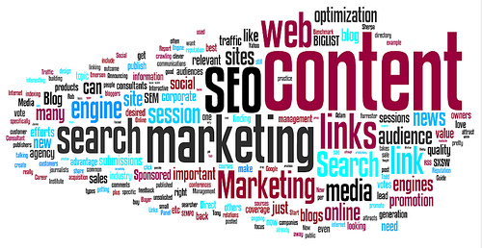
US online advertising soared 23% to $15 billion in the third quarter -- the highest quarterly spend ever. In the first half of 2015, the biggest growth was in mobile spending, which rose 54% to $8.2 billion. "Brands and agencies are focusing ever more attention on interactive screens, following consumers as they flock to digital platforms to be entertained, engaged and informed," said Sherrill Mane of the Interactive Advertising Bureau.
Marketing Land 12/10/15
http://marketingland.com/us-digital-advertising-revenues-hit-15-billion-for-another-record-quarter-iab-155667

