Online "Tribe" Platforms Vary by Generation
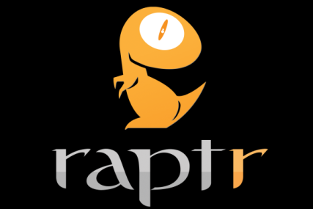
Facebook is the most prevalent platform for people looking for online tribes, research from Brodeur Partners finds. The research revealed generational gaps, however, with millennials favoring networks like Instagram, and Boomers more apt to be found on Raptr and Playfire.
PRWeek 12/29/16
http://www.prweek.com/article/1419430/study-different-generations-join-online-tribes

