OpenAI Hopes To Win Over Hollywood
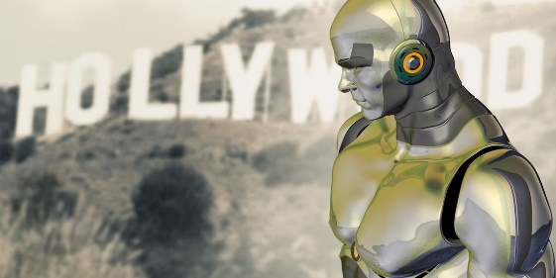
OpenAI is reportedly meeting with media executives, studios and talent agencies this week to encourage the use of OpenAI's new Sora video generation tool in television and film production. "OpenAI has a deliberate strategy of working in collaboration with industry through a process of iterative deployment - rolling out AI advances in phases - to ensure safe implementation and to give people an idea of what's on the horizon," an OpenAI spokesperson says.
BNN Bloomberg (Canada)/Bloomberg 3/22/24
https://www.bnnbloomberg.ca/openai-courts-hollywood-in-meetings-with-film-studios-directors-1.2050543
Image copyright:
https://static1.makeuseofimages.com/wordpress/wp-content/uploads/2015/03/artificial-intelligence-hollywood.jpg?q=50&fit=contain&w=1140&h=&dpr=1.5

