OTT Devices Reach 64M Homes With 7% Annual Growth
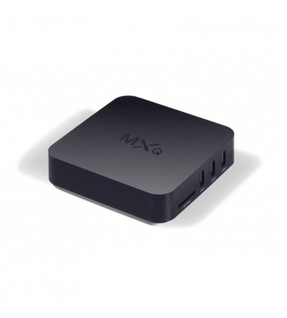
The number of US homes using over-the-top devices reached 64 million in March, Comscore says in its new State of OTT report, in which the research firm described the streaming technology as "mainstream." OTT adoption has almost caught up to DVRs in the number of units in homes, but has surpassed DVRs in actual usage.
Multichannel News 7/2/19
https://www.multichannel.com/news/comscore-declares-ott-mainstream-in-us
Image Credit:
https://www.buyon.pk/image/cache/data/members/asim586433/tv-device-360x400.jpg

