Over 50 Pay-TV Operators Plug Into MobiTV Connect
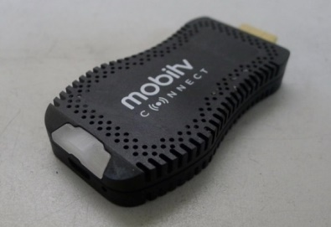
More than 50 pay-TV operators are using the MobiTV Connect platform, which allows the user to access their pay-TV subscriptions without a set-top box, per MobiTV. Among those using the platform: All West Communications, Fidelity Communications and USA Communications, with total use accounting for about 1 million users nationwide.
FierceVideo 7/30/18
https://www.fiercevideo.com/cable/mobitv-has-lured-more-than-50-pay-tv-operators-onto-its-app-based-tv-platform

