Over A Third Of US Netflix Users Don’t Pay Full Price, If At All
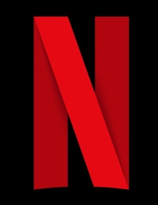
Almost one-quarter of US adult Netflix users aren’t paying to use the platform. The majority, or63%, pay full cost, while 14% share the fee with other users. Netflix’s challenge is to figure out how to get freeloaders to pay their dues.
eMarketer 5.2.22
https://www.emarketer.com/content/netflix-users-full-price/?IR=T&utm_source=Triggermail&utm_medium=email&utm_campaign=II20220503NetflixPasswordsCOTD&utm_content=A&utm_term=COTD%20Active%20List

