Pai To Team: Let’s Close The Digital Divide
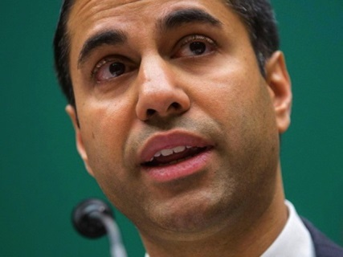
In a speech to the FCC staff yesterday, newly appointed FCC Chairman Ajit Pai laid out one of his top priorities: bringing the benefits of the digital age to all Americans. Pai said there is a digital divide in this country — between those who can use services from cutting-edge communications services and those who can not.
RadioInk 1.25.17
http://radioink.com/2017/01/25/pai-team-lets-close-digital-divide/?utm_source=ActiveCampaign&utm_medium=email&utm_content=How+Much+Ad+Revenue+Did+Radio+Receive+in+2016%3F&utm_campaign=Wednesday+Pai

