PBS's Ken Burns and His American Canon
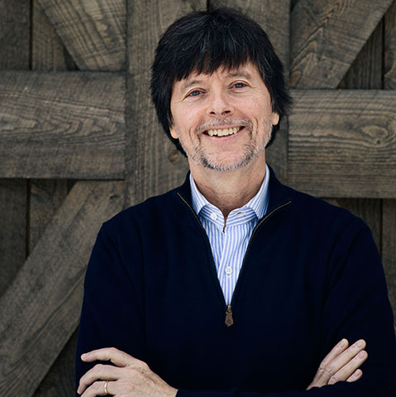
Even in a fractious era, the filmmaker still believes that his documentaries can bring every viewer in. “Documentaries are traditionally advocacy,” Burns says. He sees his films as acts of “emotional archeology” that aspire to be art. When Paula Kerger, PBS’s president, recently introduced Burns in Los Angeles, she quoted a tweet that described him as “the Marvel Studios of PBS.”
The New Yorker 8.29.17
http://www.newyorker.com/magazine/2017/09/04/ken-burns-american-canon
Image source:
http://media.independent.com/img/photos/2016/06/14/KenBurns_BarnExt02_photoTimLlewellynPhotography.jpg

