Peacock Will Stream Original Films in September
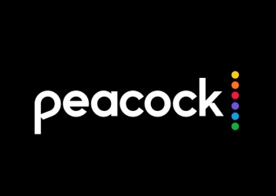
NBCUniversal's Peacock will introduce five original films next month, starting with the Sept. 4 debut of "Anthony," a drama about the racially motivated murder of a Black student in England in 2005. Other offerings include a documentary about Harry Belafonte's time as host of "The Tonight Show" and a film from Emilio Estevez about civil disobedience.
Variety online 8.21.20
https://variety.com/2020/tv/news/peacock-film-slate-emilio-estevez-the-public-harry-belafonte-tonight-show-doc-1234743208/

