Photojournalist Arrested While Covering Climate Demonstration
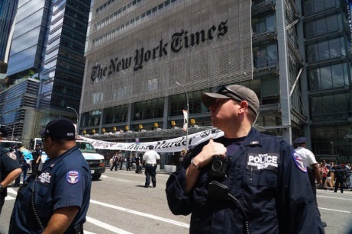
Independent photojournalist Michael Nigro said that he was wearing two press badges around his neck — one from the National Press Photographers Association and one given to accredited journalists by the NYPD. He showed the badges to the officers and asserted his right to film the protest. After some back-and-forth discussion with the officers, he agreed to leave the area. Unexpectedly, the officers then arrested him for trespassing.
U.S. Press Freedom Tracker 7.9.19
https://pressfreedomtracker.us/all-incidents/photojournalist-arrested-while-covering-climate-demonstration-equipment-seized/
Image credit:
https://pressfreedomtracker.us/media/images/Nigro_arrest2.original.jpg

