PIRATE Act Could Boost Illegal Radio Broadcast Fines to $2M
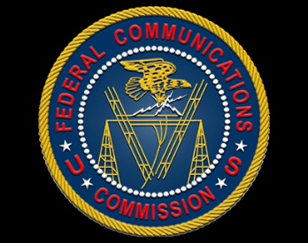
A group of bipartisan lawmakers has proposed the Preventing Illegal Radio Abuse Through Enforcement Act, which would allow the Federal Communications Commission to fine pirate radio operators up to $2 million. If the bill becomes law, the FCC will be able to fine pirate radio violators who operate "willfully and knowingly" up to $100,000 for each day they are on the air, up to a $2 million cap.
Inside Radio 5/9/18
http://www.insideradio.com/free/pirates-would-face-million-fines-under-congressional-proposal/article_6bd8e1c8-5333-11e8-baaa-47d19292741e.html

