FCC Ramps Up Fight Against Broadcast Pirates
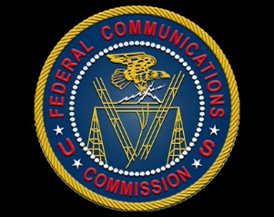
A new FCC database identifies entities the agency has taken action against for radio piracy. The agency is hiring field agents and planning to purchase specialized vehicles to sweep major markets for illegal broadcasts.
Radio World 1/25/23
https://www.radioworld.com/news-and-business/headlines/fcc-publishes-pirate-enforcement-database?utm_term=A25693A1-51B6-4112-BDE4-56BD420E983F&utm_campaign=45863C53-9E40-4489-97A3-CC1A29EF491D&utm_medium=email&utm_content=A4D3583C-271E-494B-922B-BA2219D1F603&utm_source=SmartBrief
FCC Database
https://www.fcc.gov/pirate-database

